A000-MEX-Chontal-Oaxaca-Mask-Serpentine-800-900 CE

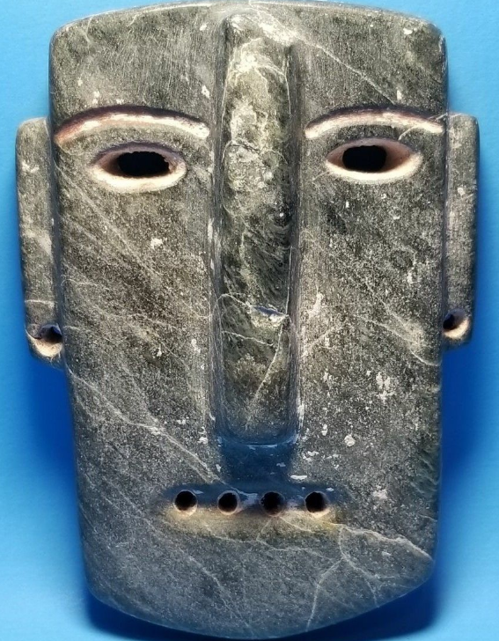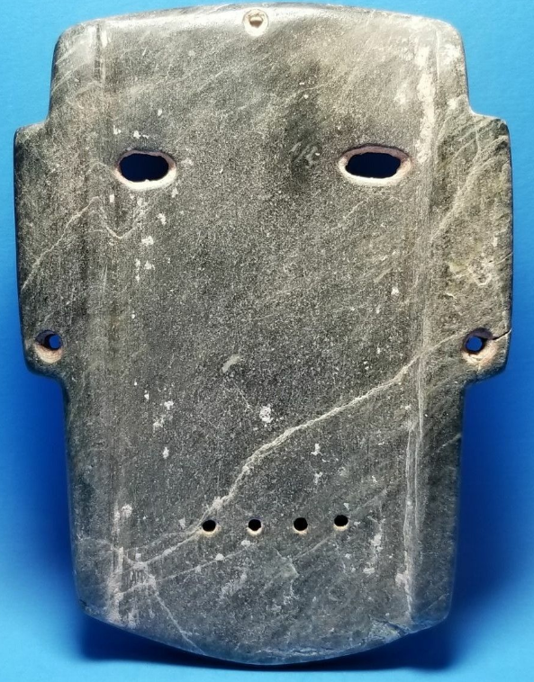

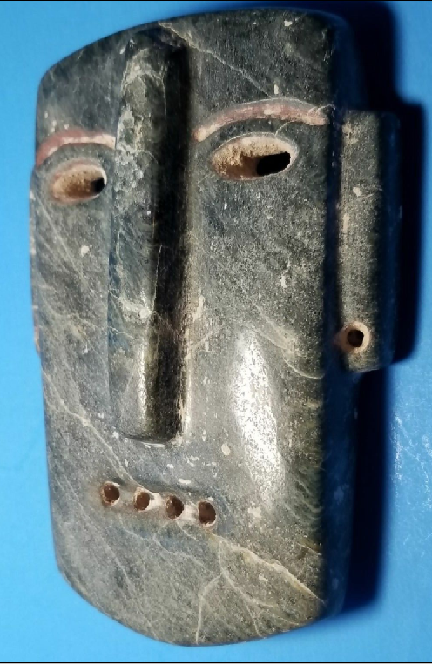

Figs. 1-4. MEX-Chontal-Oaxaca-Mask-Serpentine-800-900 CE

**Case No.: 14**

**Accession No.**

**Formal Label:** MEX-Chontal-Oaxaca-Mask-Serpentine-800-900 CE

In SE Oaxaca, Chontal people occupy the highlands of the southern Sierra Madre and the coastal plains that stretch to the Pacific Ocean (literally, “strangers”, from the Nahuatl term *chontalli*). In these ruggedly intersected areas local communities are isolated, and their ceremonial rituals and masks are also distinguished by local traditions, which have, however, mutual motifs. Masks, for instance, as in this example, have drilled holes for mouth and ear piercings, elongated openwork eyes and vertically elongated noses. In all these features these Chontal masks differ from Mezcala masks which have mainly horizontally organized features and very few drilled holes except for holding a pendant cord. On the coast Huamelula and Astatahave were settled 300–800 CE in nucleated residential zones situated close to ceremonial precincts that developed near the fertile alluvial deposits along riverbanks. [Highland Oaxaca Chontal](http://glottolog.org/resource/languoid/id/high1242) villages were settled somewhat later, ca 800-900 CE, leading some scholars to hypothesize that the settlement of the Chontal speaking peoples canoed south along the coast and then traveled up the coastal streams inland into the rugged highland Oaxaca Mountains.

**Accession Number:**

**LC Classification:** F1219.1

**Date or Time Horizon:**

**Geographical Area:**

**Map:**

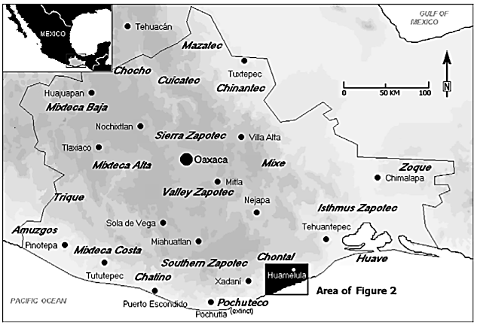

Distribution of ethno-linguistic groups and the location of the Chontal region in Oaxaca, southern Mexico. After O’Connor and Kroefges 2008, Fig. 1.

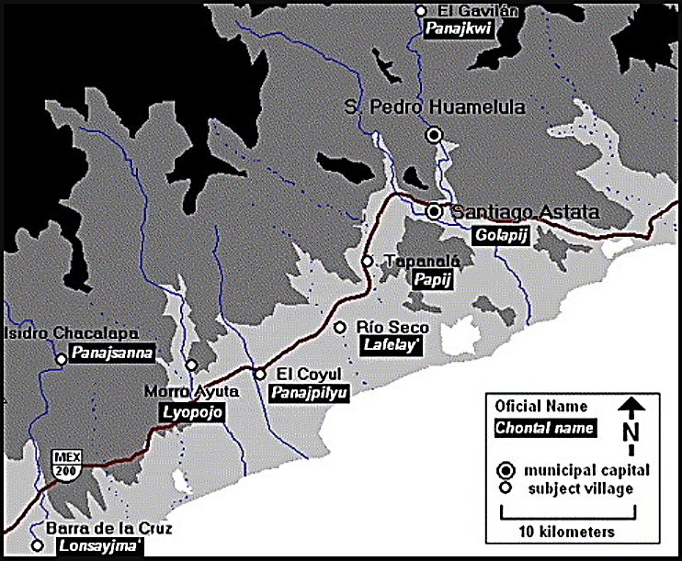

Distribution of ethno-linguistic groups and the location of the Chontal coastal region in Oaxaca, southern Mexico. After O’Connor and Kroefges 2008, Fig. 2.

**GPS coordinates:** 16°11'N, 95°44'W

**Cultural Affiliation:** [Highland Oaxaca Chontal](http://glottolog.org/resource/languoid/id/high1242)

**Medium:** stone

**Dimensions:** H 3 ½ in, W 3 in

**Weight:**

**Condition: original**

**Provenance:** Panajkwi (El Gavilan), from a collection that was formed in in the 1960's.

**Discussion:**

Chontal of Oaxaca is a genetically unclassified language with two surviving varieties: Highland Chontal (also known as Tequistlateco) in the elevated Sierra Madre del Sur, and Lowland Chontal (or Huamelulteco) along the Pacific coast. The rugged mountain highlands cover about 2000 km2 where altitudes rise to 3700 m above sea level. The coastal lowlands are not homogeneous but riven by rugged foothills (50–1000 m above sea level) and cover 870 km2 (O’Connor and Kroefges 2008).

**References:**

Bartolomé, Miguel y Alicia Barabas. 1992. *Narrativa chontal, Oaxaca, México, Consejo Nacional para la Cultura y las Artes-Instituto Nacional de Antropología e Historia-Oaxaca* (Serie Narrativas Étnicas, 3).

Bartolomé, Miguel y Alicia Barabas. 1993. *Historia chontal, Oaxaca, México, Consejo Nacional para la Cultura y las Artes-Instituto Nacional de Antropología e Historia-Oaxaca* (Serie Historias Étnicas, 5).

Bartolomé, Miguel y Alicia Barabas. 1999. *La pluralidad en peligro. Procesos de transfiguración y extinción cultual en Oaxaca (chochos, chontales, ixcatecos y zoques).* México City: Instituto Nacional de Antropología e Historia / Instituto Nacional Indigenista.

Byland, Bruce E., Danny Zborover and Peter C Kroefges. 2015. *Bridging the gaps: integrating archaeology and history in Oaxaca, Mexico: a volume in memory of Bruce E.* *Byland*. Boulder: University Press of Colorado Carrasco, Pedro. 1960. *Pagan Rituals and Beliefs among the Chontal Indians of Oaxaca, Mexico*. University of California Anthropological Records 20(3).

Kroefges, Peter. 1998. “El Lienzo de Tecciztlan y Tequatepec. Un documento histórico-cartográfico de la Chontalpa de Oaxaca.” In Maarten Jansen, ed., *The Shadow of Monte Alban: Politics and Historiography in Postclassic Oaxaca, México*. Leiden, the Netherlands: Research School CNWS, School of Asian, African and Amerindian Studies,

Kroefges, Peter. 2006. *Archaeological investigations in the Río Huamelula Valley: settlement history and material culture in south-eastern Oaxaca, Mexico*. Oxford: Archaeopress.

O’Connor, L. and Kroefges, P.C. 2008. “The land remembers: landscape terms and place names in Lowland Chontal of Oaxaca, Mexico,” *Language Sciences*, *30*(2-3): 291-315.

Throckmorton, Spencer. 1991. *Transformations: stone figures from Mezcala/Chontal*; photographs by John Bigelow Taylor. New York, NY: Kubaba Books.**Accession Number:**

**LC Classification:**

**Date or Time Horizon:**

**Geographical Area:**

**Map:**



Distribution of ethno-linguistic groups and the location of the Chontal region in Oaxaca, southern Mexico. After O’Connor and Kroefges 2008, Fig. 1.



Distribution of ethno-linguistic groups and the location of the Chontal coastal region in Oaxaca, southern Mexico. After O’Connor and Kroefges 2008, Fig. 2.

**GPS coordinates:** 16°11'N, 95°44'W

**Cultural Affiliation:** [Highland Oaxaca Chontal](http://glottolog.org/resource/languoid/id/high1242)

**Medium:** stone

**Dimensions:** H 5 ½ in, W 4 in

**Weight:**

**Condition: original**

**Provenance:** Golapij (Santiago Astata)

**Discussion:**

Chontal of Oaxaca is a genetically unclassified language with two surviving varieties: Highland Chontal (also known as Tequistlateco) in the elevated Sierra Madre del Sur, and Lowland Chontal (or Huamelulteco) along the Pacific coast. The rugged mountain highlands cover about 2000 km2 where altitudes rise to 3700 m above sea level. The coastal lowlands are not a homogeneous but split by rugged foothills (50–1000 m above sea level) and cover 870 km2 (O’Connor and Kroefges 2008).

**References:**

Bartolomé, Miguel y Alicia Barabas. 1992. *Narrativa chontal, Oaxaca, México, Consejo Nacional para la Cultura y las Artes-Instituto Nacional de Antropología e Historia-Oaxaca* (Serie Narrativas Étnicas, 3).

––––––––––. 1993. *Historia chontal, Oaxaca, México, Consejo Nacional para la Cultura y las Artes-Instituto Nacional de Antropología e Historia-Oaxaca* (Serie Historias Étnicas, 5).

––––––––––. 1999. *La pluralidad en peligro. Procesos de transfiguración y extinción cultual en Oaxaca (chochos, chontales, ixcatecos y zoques).* México City: Instituto Nacional de Antropología e Historia / Instituto Nacional Indigenista.

|  |
| --- |
| Byland, Bruce E., Danny Zborover and Peter C Kroefges. 2015. *Bridging the gaps: integrating archaeology and history in Oaxaca, Mexico: a volume in memory of Bruce E.* *Byland*. Boulder: University Press of Colorado. |

Carrasco, Pedro. 1960. *Pagan Rituals and Beliefs among the Chontal Indians of Oaxaca, Mexico*. University of California Anthropological Records 20(3).

Kroefges, Peter. 1998. “El Lienzo de Tecciztlan y Tequatepec. Un documento histórico-cartográfico de la Chontalpa de Oaxaca.” In Maarten Jansen, ed., *The Shadow of Monte Alban: Politics and Historiography in Postclassic Oaxaca, México*. Leiden, the Netherlands: Research School CNWS, School of Asian, African and Amerindian Studies,

Kroefges, Peter. 2006. *Archaeological investigations in the Río Huamelula Valley: settlement history and material culture in south-eastern Oaxaca, Mexico*. Oxford: Archaeopress.

O’Connor, L. and Kroefges, P.C. 2008. “The land remembers: landscape terms and place names in Lowland Chontal of Oaxaca, Mexico,” *Language Sciences*, *30*(2-3): 291-315.

Throckmorton, Spencer. 1991. *Transformations: stone figures from Mezcala/Chontal*; photographs by John Bigelow Taylor. New York, NY: Kubaba Books.